Hardware 100 fit view

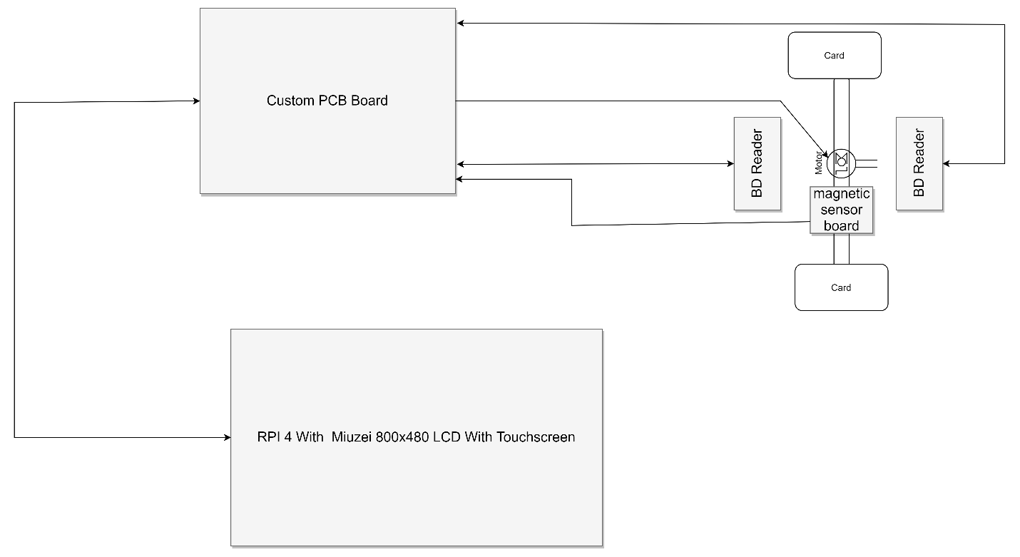

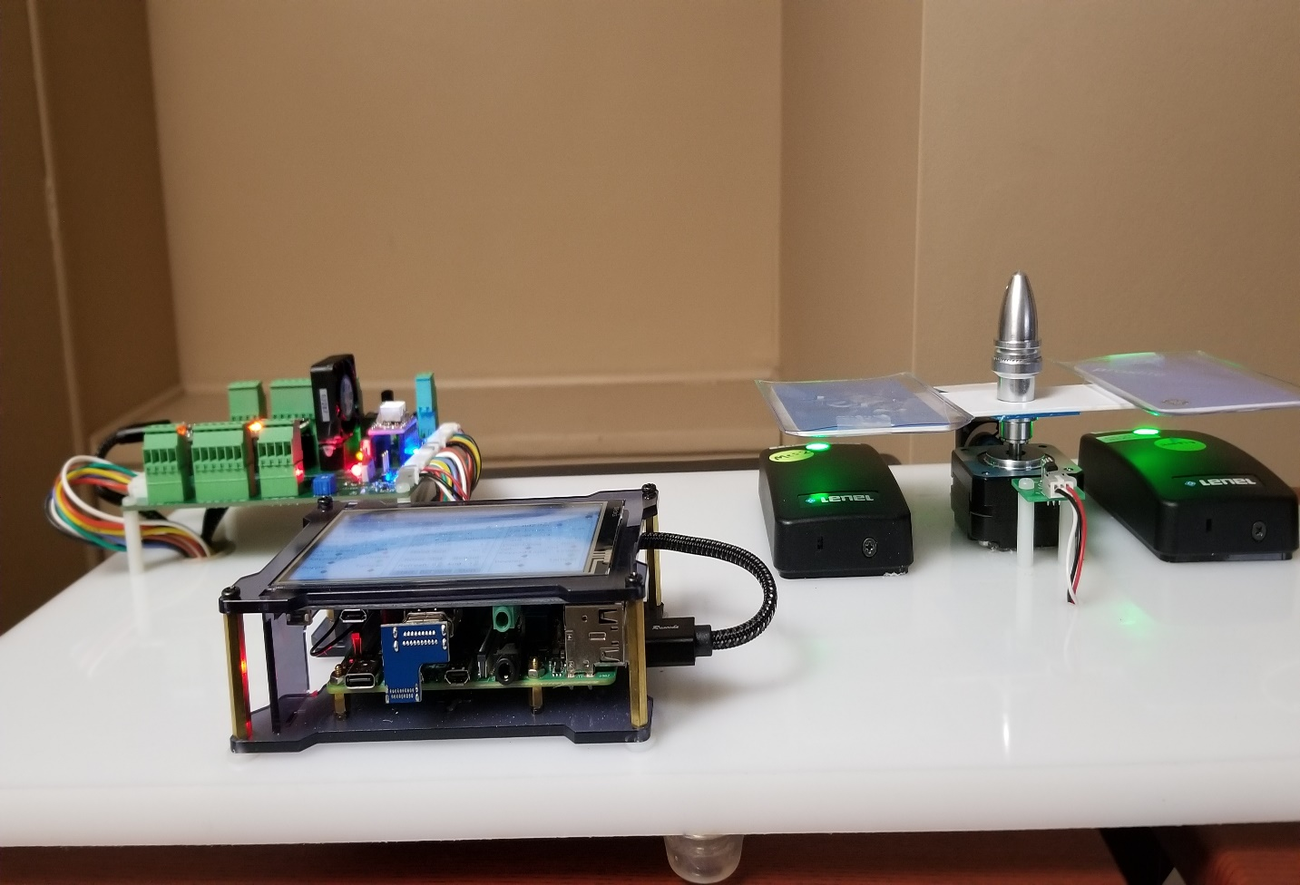
Figure 1

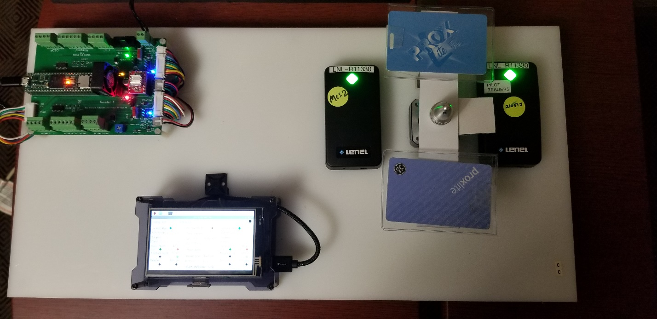
Figure 2

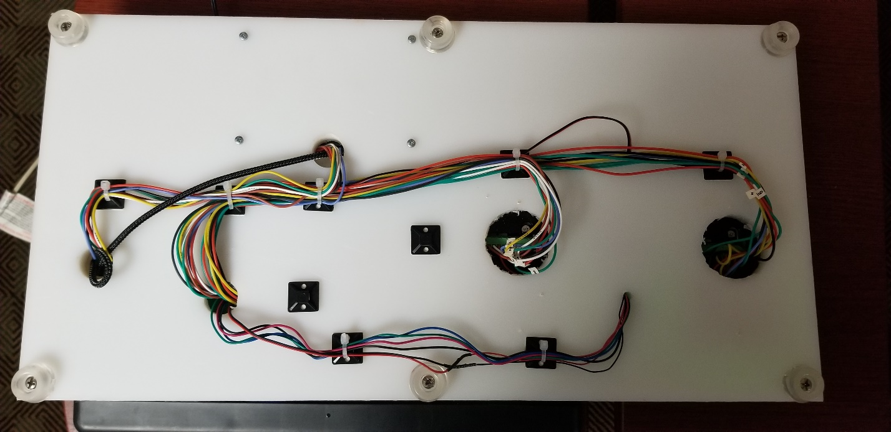
Figure 3

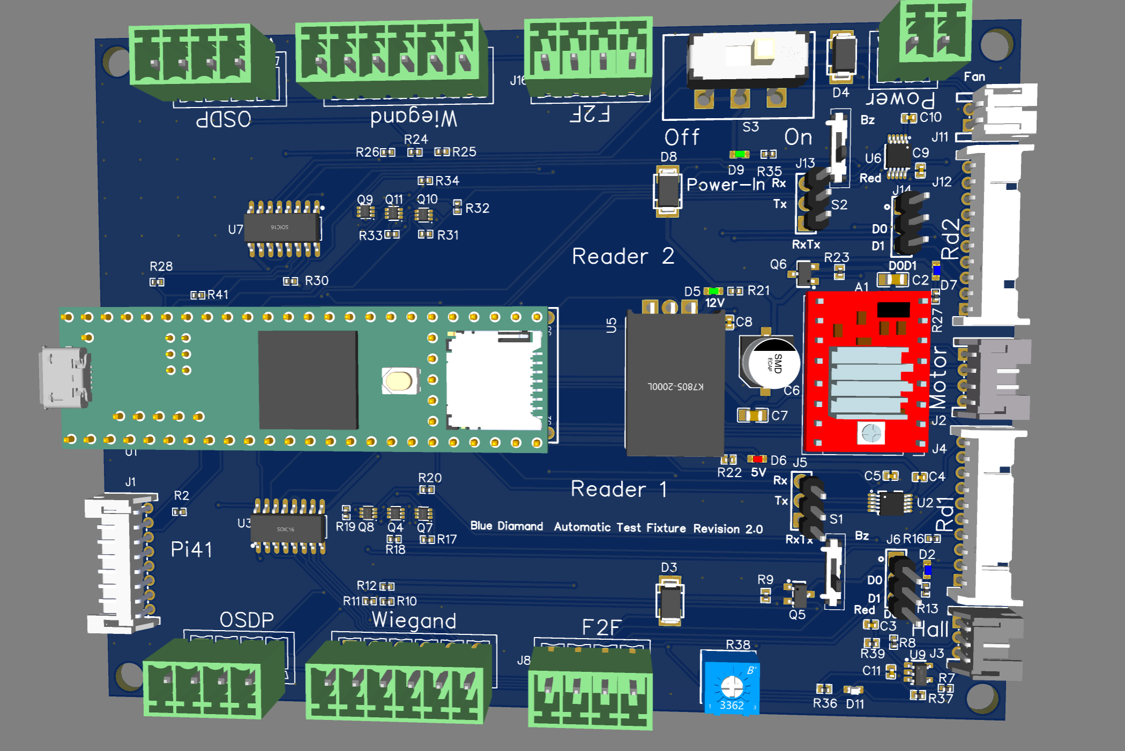
Figure 4
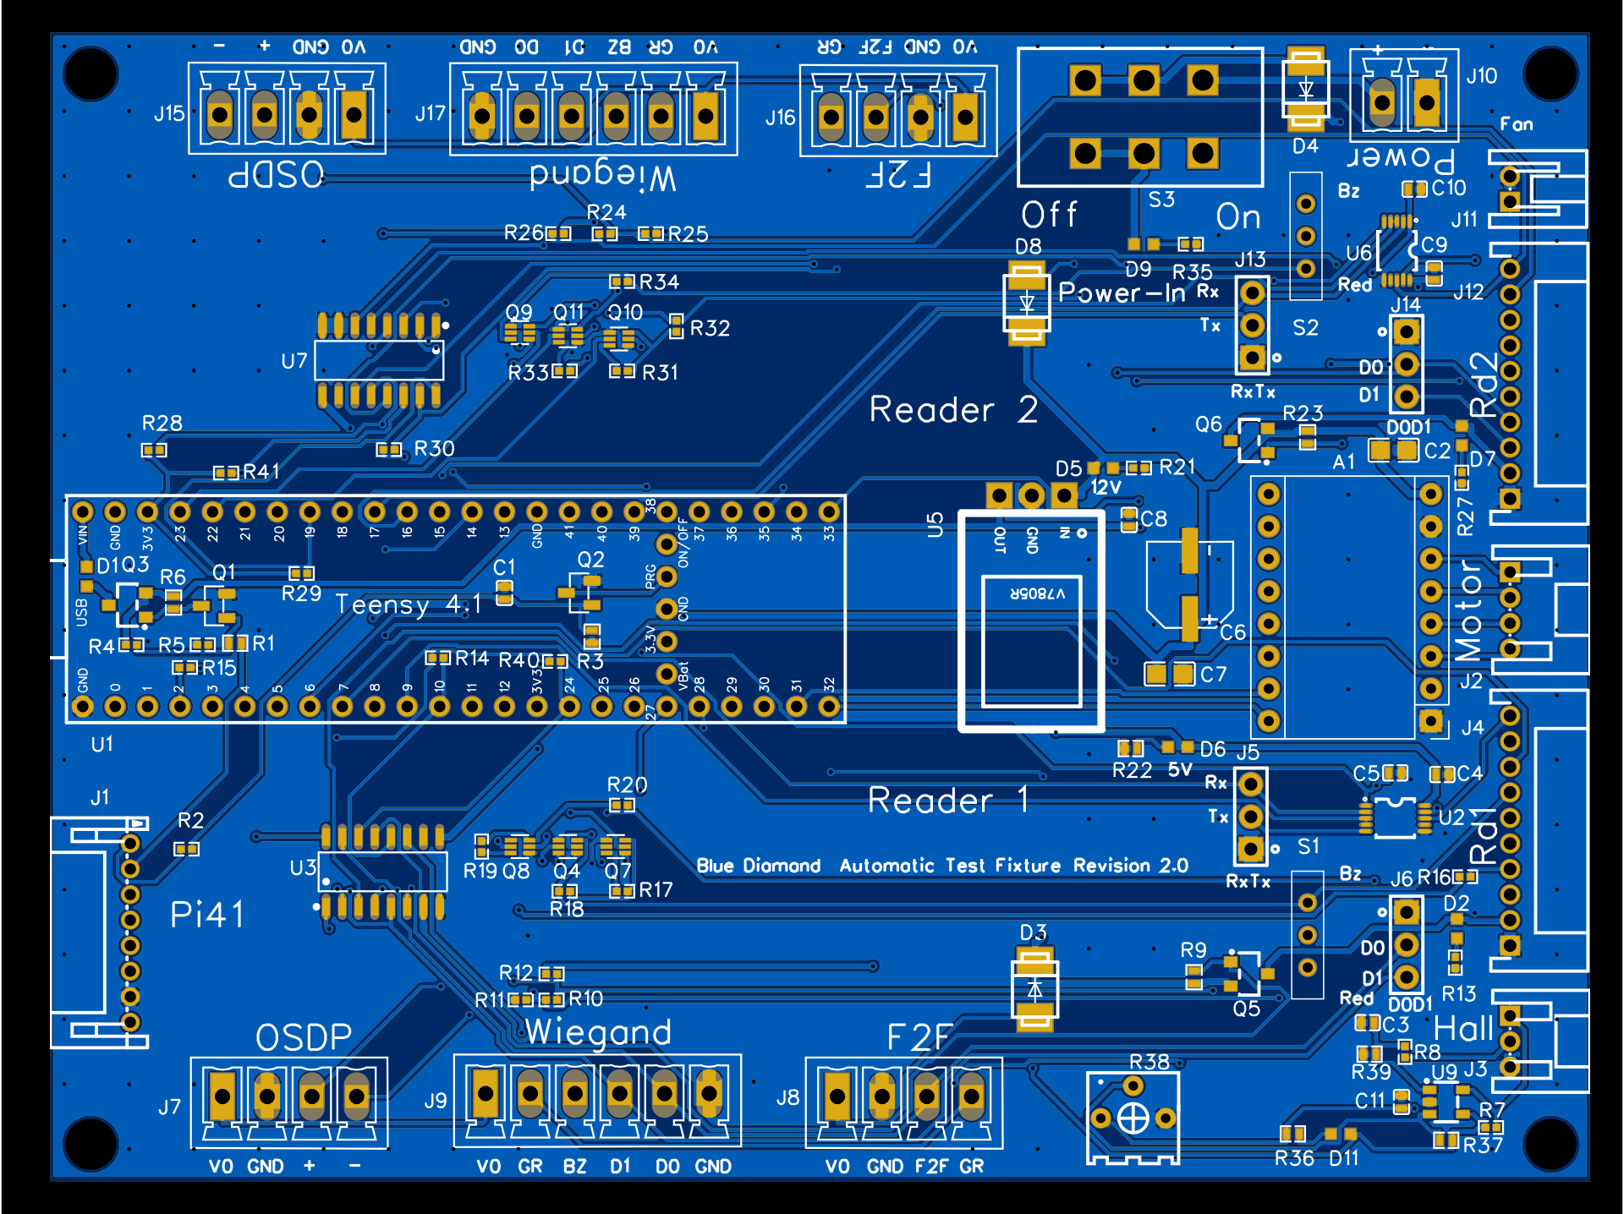
Figure 5

Overview
The Blue Diamond test fixture is designed to test Blue Diamond readers functionality. The custom board has HW and FW to spin the stepper motor and perform the badge swipes. The reader’s output is read by the custom board, the protocol is decoded and “ack” send to the reader if required.
The Test fixture has two operating modes; the loopback mode and pass-through mode. In the loopback mode the Test Fixture custom board will emulate OnGuard and Reader HW functionality. In the pass-through mode the custom board shall be connected to the Mercury controller reader ports. In this mode the Test Fixture controls the motor to swipe badges and spies on the communication between the readers and Mercury controller.
Limitations:
The loopback mode is only supported for F2F readers. In the future OSDP and Wiegand protocols will be supported.

PCBs
There are two PCB boards; the custom board and the sensor (HAL effect) board. The boards are designed with online CAD tool easyeda.com The Gerber files, the project files and BOMs are located in the directory Cad.
The boards shall be assembled according to the provided documentation. Adjust R38 to make sure the voltage on U9.3 is about 2.8V.

Harnesses
There is no harnesses drawings yet. All connectors are JST 2mm PH series, the socket’s part number is JST SPH-002T-P0.5L. Use 26 or 24 GA Silicon wires. The wires like rc servo wires are the best, strong and flexible.

Raspberry PI
The Raspberry Pi model is Pi 4 with 2GB memory. Miuzei Raspberry Pi 4 Touchscreen with Case & Fan, 4-inch IPS Touch Screen LCD is also required. The operating system must be 64 bit Raspbian from https://downloads.raspberrypi.org/raspios_arm64/images/

Assembly
- To be completed

Software Overview.

There are two 4 software units in the BD Test fixture
See diagram below:

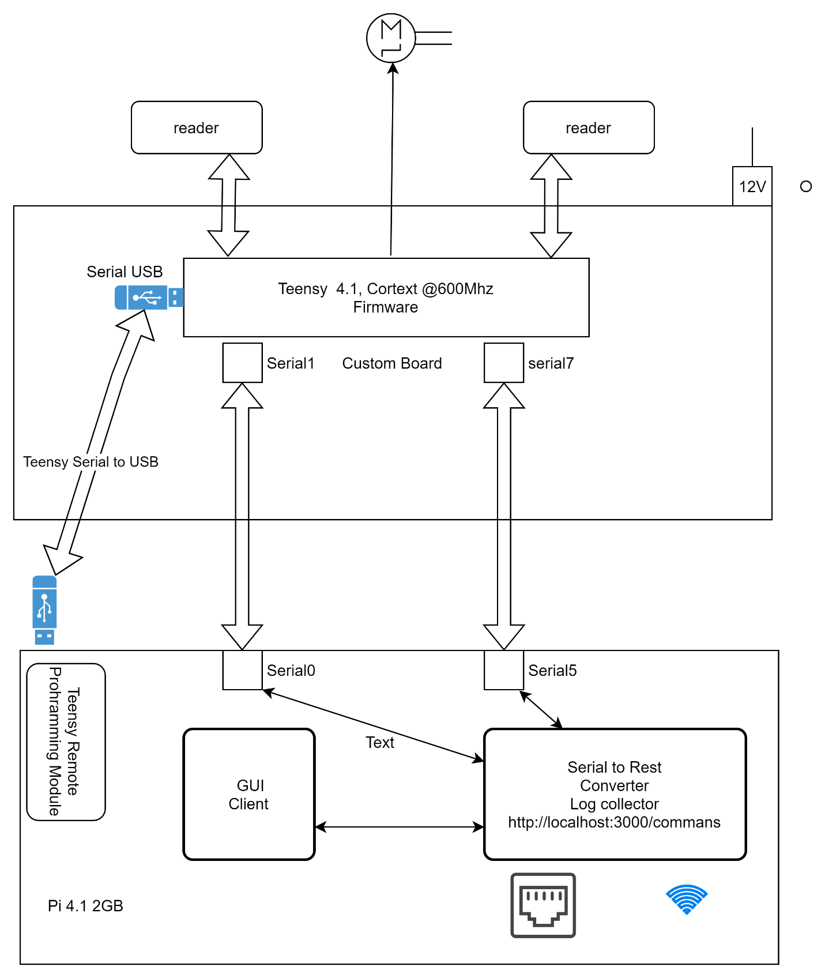
Figure 6
- Teensy Firmware
- Client Gui app
- teensyServer app
- teensy cli app

Teensy firmware controls all functionality of the test fixture;
Custom board does not need Pi to operate the test fixture. Pi exists to make the test fixture operation independent from external PC and can be controller from Pi touch-screen LCD.

Pi LCD Setup

Download Pi image from https://downloads.raspberrypi.org/raspios_arm64/images/ Use Pi imager and burn the image to the SD-Card.
Insert Sd-Card into Pi and power up.
You will have to use PI micro-hdmi cable, keyboard and the mount to continue setup.
- Power up Pi. Follow on screen instructions to set the locally and change the password.
- Set the WiFi and follow the system update.
- Use raspi-config app and enable ssh server
- Use raspi-config app and disable shell on serial port and enable serial port.
- Run commands below
sudo apt install xserver-xorg-input-evdev
sudo apt install xinput-calibrator

sudo rm -rf LCD-show
git clone https://github.com/goodtft/LCD-show.git
chmod -R 755 LCD-show
cd LCD-show/
#open MPI4008-show and remove comment line 55 sudo dpkg -i -B ./xserver-xorg-input-evdev_1%3a2.10.6-1+b1_armhf.deb
sudo ./MPI4008-show

Use nano and open /boot/config.txt
Find [all] and replace all lines below with the lines:
dtparam=audio=on
camera_auto_detect=1
#dtoverlay=vc4-kms-v3d
arm_64bit=1

[pi4]
# Run as fast as firmware / board allows
arm_boost=1

[all]
hdmi_force_hotplug=1
hdmi_force_edid_audio=1
dtparam=i2c_arm=on
dtparam=spi=on
enable_uart=1
display_rotate=1
max_usb_current=1
config_hdmi_boost=7
hdmi_group=2
hdmi_mode=1
hdmi_mode=87
hdmi_drive=2
hdmi_cvt 480 800 60 6 0 0 0
dtoverlay=ads7846,cs=1,penirq=25,penirq_pull=2,speed=50000,keep_vref_on=0,swapxy=0,pmax=255,xohms=150,xmin=200,xmax=3900,ymin=200,ymax=3900
gpio=17=op,dl
gpio=6=op,dh
dtoverlay=uart5
dtoverlay=disable-bt
initramfs initrd.img-5.10.63-v8+-overlay

- Reboot Pi.
- gsettings set org.gnome.desktop.screensaver lock-enabled false
- gsettings set org.gnome.desktop.lockdown disable-lock-screen 'true'
- gsettings set org.gnome.desktop.screensaver idle-activation-enabled false

- Connect to PI a keyboard and a mouse. Run menu->Preferences->Calibrate Touchscreen. Follow the screen. Make sure to put calibration data into the /etc/X11/xorg.conf.d

Nodejs Installation

curl -sL https://deb.nodesource.com/setup_14.x -o nodesource_setup.sh
bash nodesource_setup.sh
apt-get install nodejs

Pi Lazarus Setup
In order to build client application Lazarus Free Pascal shall be installed on Pi and the PC. Follow steps below. (note the for the PC the fpc binary shall be for the PC)
- Download the FPC binaries from https://www.freepascal.org/down/aarch64/linux-hungary.html or other mirror
- Run commands below
- mkdir Lazarus
- cd Lazarus
- wget ftp://ftp.hu.freepascal.org/pub/fpc/dist/3.2.2/aarch64-linux/fpc-3.2.2.aarch64-linux.tarcd fpc-3.2.0.aarch64-linux

- tar -xf fpc-3.2.2.aarch64-linux.tar; cd fpc-3.2.2.aarch64-linux
- sudo sh install.sh

- Download and unpack the FPC source from ftp://ftp.hu.freepascal.org/pub/fpc/dist/3.2.2/source/fpcbuild-3.2.2.tar.gz

- Download and compile Lazarus

- sudo apt install libqt5pas-dev libqt5pas1
- git clone https://github.com/ultibohub/LazarusIDE
- cd LazarusIDE/
- make LCL_PLATFORM=qt5

Teensy 4.1 Firmware Build Environment
The firmware build instructions are provided for Linux OS. It is very possible to build firmware on Windows. This is possible on Windows 10 and Linux on Windows subsystem.

Building Firmware
To setup the build environment follow steps bellow:
- Install cmake rev 3.22 or newer
- Install Arduino IDE (https://www.arduino.cc/en/software), currently 1.8.19
- Install Teensyduino (https://www.pjrc.com/teensy/td_download.html)
- Make sure to install udev rules for teensy
- Make a symbolic link arduino-ide to arduino folder.
- Download and install teensy_loader_cli (https://github.com/PaulStoffregen/teensy_loader_cli) and install the tool into ~/ arduino-ide/hardware/tools
- Build core libraries. To build the core libraries run the script #f2fSimPanel/teensy/ buildLib.sh 4 1 4 1 is argument to build core libs for teensy 4.1
- Create directory #f2fSimPanel/teensy/build and cd to this directory
- Run #cmake -DCMAKE_TOOLCHAIN_FILE=../cross/arm-teensy41-gnueabihf.cmake -DCMAKE_BUILD_TYPE=Release ../
- Run #make

Programming Teensy
There are two ways to program Teensy 4.1
- Direct. Connect Teensy to the PC with USB cable. Run command # teensy_loader_cli -mmcu TEENSY41 -w -s -v HEXFILE-Name
- Use Test fixture Pi. Run script # ${PROJECT_SOURCE_DIR}/program.sh TEENSY41 HExFILe-Name-No-Dir ${PROJECT_SOURCE_DIR}
PROJECT_SOURCE_DIR is a path to the directory which has directory build in which there is a hexfile

Pi Client app
This app runs on the Pi LCD.
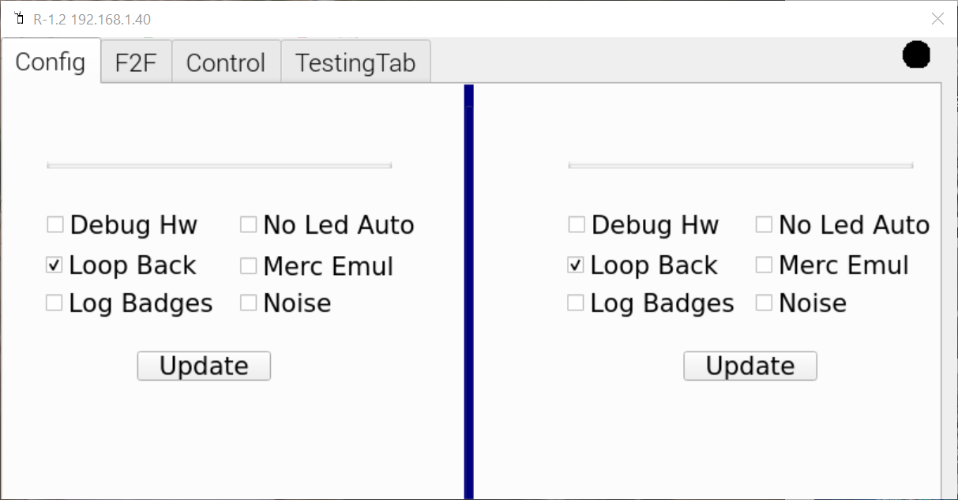
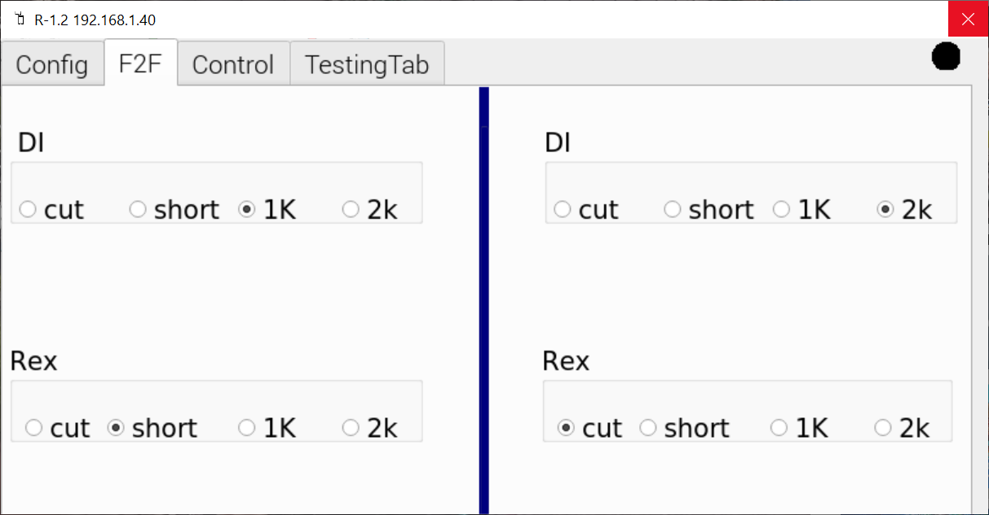
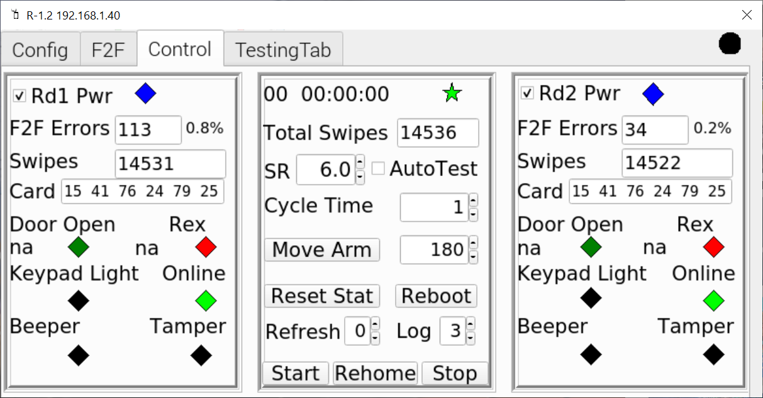
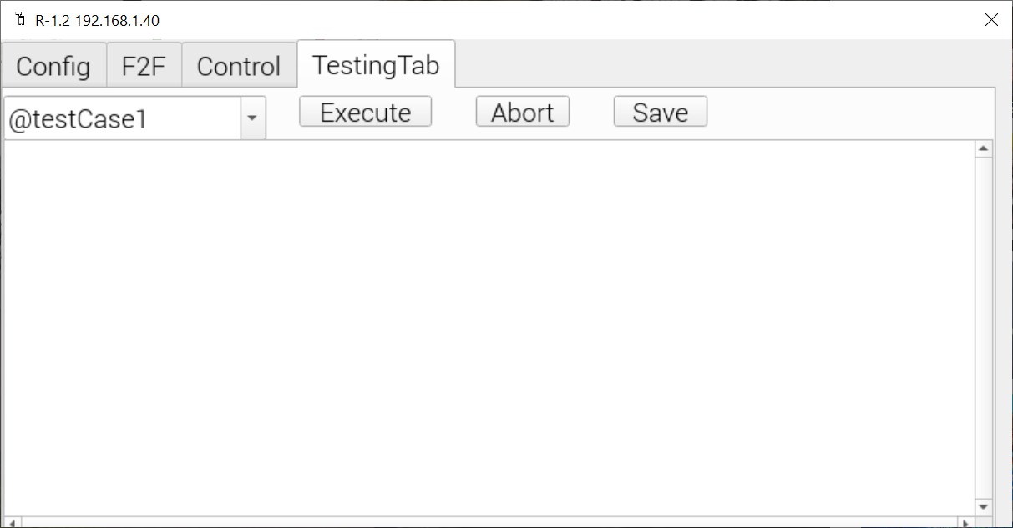Will Run NodeJs Cucumber test cases.

Test Fixture API
Hardware configuration:
- Teensy Serial1 port is connected to Pi Uart1 - "/dev/serial0"
- Teensy Serial7 port is connected to Pi Uart5 - "/dev/ttyAMA1"
Serial7 is used for logging only
Serial1 is used for the command terminal. See command terminal below.
There is a nodejs app which is run as a service “teensyServer”.
In the development or debugging it makes sense to see the Teensy log in picocom and have direct access to Teensy commands terminal. In this case stop teensyServer with systemctl and connect to UART1 and UART5 directly with picocom. See config file below for devices and baudrates
NodeJs app (teensyServer) will
- Read the data from Teensy Serial7 port and put it to file.
- Connected to the Teensy command terminal
- Implements Rest server on http://localhost:3000/commands

Look at the config file #cat /etc/bdArm.json
{
"gui": {
"fixtureURL": "http://localhost:3000/commands",
"testingDirectory": "/home/pi/myGitHub/f2fSimPanel/pi/testing/",
"logDir": "/home/pi/lenel"
},
"cucumber": {
"hostServer": "localhost",
"retryDelay": 100,
"retries": 20,
"timeout": 5000,
"logFilePath": "/home/pi/lenel/cucumbertest.log"
},
"teensyServer": {
"tcpPort": 3000,
"teensyPullInterval": 30,
"myUdpPort": 10000,
"serialDev": "/dev/serial0",
"serialBaud": 256000,
"logSerialDev": "/dev/ttyAMA1",
"logSerialDevBaudRate": 256000,
"teensyProgGpio": 17,
"teensyPowerGpio": 6,
"serialPullInt": 20,
"serialInterbyteTimeout": 50,
"teensyLogFilename": "/home/pi/lenel/teensyLog.log",
"teensyServerLogFilename": "/home/pi/lenel/teensyServer.log",
"teensyServerLogDebugFilename": "/home/pi/lenel/teensyServerDebug.log"
}
}

The Rest Server expect json input, see example below

#!/bin/sh
set -e

if [ "$1" = "h" ] || [ -z "$1" ] || [ -z "$2" ]; then
echo "$0 command piIp argument=null timeout = 10000"
exit 1
fi

timeoutValue="$4"
if [ -z "$4" ]; then
timeoutValue=1000
fi

argument="$3"
if [ -z "$3" ]; then
argument=null
fi

curl --header "Content-Type: application/json" --request POST --data "{\"cmd\":\"${1}\", \"arg\": \"${argument}\", \"timeout\": \"${timeoutValue}\"}" http://${2}:3000/commands

The script expect argument: command Pi-Ip command-argument timeout = 10000

Commands Terminal
Ssh to Pi and kill teensyServer. Get 2 ssh terminals.
In one terminal run #picocom -b 25600 /dev/ttyAMA1 #teensy log
In second terminal run #picocom -b 25600 /dev/serial0 #commands terminal
Commands terminal provide complete control to Test Fixture API, just type “help” enter

